**PIZZA SALES SQL QUERY**

**A.KPI’S**

**1.Total Revenue:**

SELECT SUM(total_price) AS Total_Revenue FROM pizzal_sales;

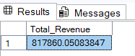

**2.Average Order Value:**

SELECT (SUM(total_price)/COUNT(DISTINCT order_id)) AS Average_Order_Value FROM pizzal_sales;

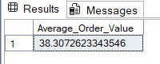

**3.Total Pizzas Sold:**

SELECT sum(quantity) as Total_Pizzas_Sold from pizzal_sales;

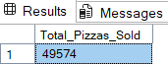

**4.Total Orders :**

SELECT COUNT(DISTINCT order_id) Total_Orders from pizzal_sales;

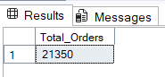

**5.Average Pizzas Per Order:**

SELECT cast(CAST(sum(quantity)as decimal(10,2))

/CAST(COUNT(DISTINCT order_id) as decimal(10,2)) as decimal (10,2)) as Avg_Pizza_Order_Per_Order

from pizzal_sales;

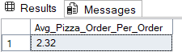

**6. Daily Trend for Total Orders:**

SELECT DATENAME(DW,order_date) as Order_Day ,count(DISTINCT order_id) AS Total_Orders

from pizzal_sales

GROUP BY DATENAME(DW,order_date);

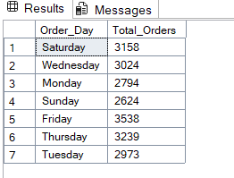

**7.Monthly Trends for Total Orders:**

select DATENAME(month,order_date) as Month_Name,COUNT(DISTINCT order_id) as Total_Orders

from pizzal_sales

GROUP BY DATENAME(month,order_date);

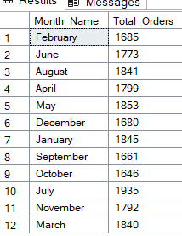

**8. % of Sales by Pizza Category:**

SELECT pizza_category ,sum(total_price) as Total_Sales,

SUM(total_price)*100/ (Select sum(total_price) from pizzal_sales where MONTH (order_date)=1) as PCT

from pizzal_sales

where MONTH (order_date)=1

group by pizza_category

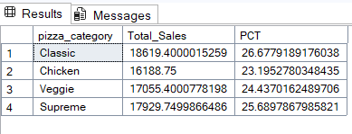

**9.  % of Sales by Pizza Size:**

SELECT pizza_size ,CAST(sum(total_price) AS DECIMAL(10,2)) as Total_Sales,

CAST(SUM(total_price)*100/ (Select sum(total_price) from pizzal_sales where MONTH (order_date)=1) AS DECIMAL (10,2)) as PCT

from pizzal_sales

where MONTH (order_date)=1

group by pizza_size

order by PCT DESC

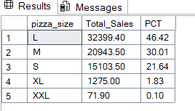

**10.Top 5 Pizzas by Revenue:**

SELECT Top 5 pizza_name, SUM(total_price) AS Total_Revenue

FROM pizzal_sales

GROUP BY pizza_name

ORDER BY Total_Revenue DESC

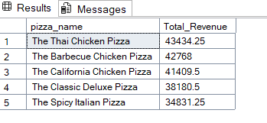

**11.Bottom 5 Pizzas by Revenue:**

SELECT TOP 5 pizza_name, SUM(total_price) AS Total_Revenue

FROM pizzal_sales

GROUP BY pizza_name

ORDER BY Total_Revenue

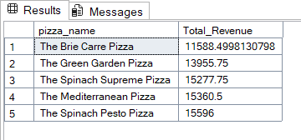

**12. TOP 5 Pizzas by Quantity**